Game title: Type Mania

Description:

This is a simple gravity game inspired by typography posters in graphic design. User needs to transport the orange ball from one end of the page to the other end using limited number of letters (each cannot be used more than twice).

Features:

1. Erase the letters you don’t want
2. Rotate letter
3. Obstacles where you cannot put any letter on
4. Inverse gravity
5. Limited no. letters
6. Each letter cannot be used more than twice
7. **Score based on the letter left and time you take and the percentage of the ball get to the end pipe**
8. **Randomly generate the level map every time player enters the level**
9. **Save screenshot of the current state and create a txt of the list of letters used and their positions**
10. **Change the color of the letters, balls and blocks in setting**
11. **Rainbow mode: make each letter player puts in rainbow color order**

Competitive analysis:

1. Pipe Mania

Just as what the name of this game is referring to, type mania borrows the concept from the classic puzzle game Pipe Mania (Pipe Dream) developed in 1989 by The Assembly Line for personal computer Amiga. In Pipe Mania, the player must construct a passable pipeline from the starting piece using the random pipe pieces generated in a queue so that the “flood” can pass through the at least the given number of pipes. Similarly, Type Mania uses types(letters) as the pipes to create a path for the ball to travel. The biggest difference between Type Mania and Pipe Mania is that Type mania is a gravity-based game that the ball only starts falling when player clicked the play button and the player can no longer add any more letters onto the canvas, while in Pipe Mania, after a period of time delay, “flood” will flow out of the starting pipe, and the player can still put the pipe piece onto the map, and it gives the limited amount time for the player to figure out the solution.

1. Linerider

Linerider was an internet game developed in 2006 which is essentially about the character sliding on the line drawing player creates. Linerider is a game about creating an interesting drawing rather than about getting the solution. Although Type Mania is mostly about solving the problem, I am trying to balance out the “creating” element and the “solving” element to let the user be able to “play” with type arrangement. Both game are based on gravity. Another feature that I borrow from the Linerider is the play button; for both game the time given to the player is unlimited, only when the player clicks the play button, the character/ball starts moving. However, the time taken to solve the problem in Type Mania is going to be used to calculate the score, the less time it takes, the higher the score.

1. Isoball

The biggest difference between Isoball and Type Mania is that Isoball takes place in 3d space while Type Mania is a 2d gravity-based ball game. What’s more, Isoball is able to use backtracking to generate random map because it is based on a systematic grid structure. However, Type Mania cannot do that because there is no grid so it is very hard to use backtracking to predict where exactly the player can place the letters.

Module List:

Pygame, **pymunk**

Version Control Plan:

I will use google drive to save all my files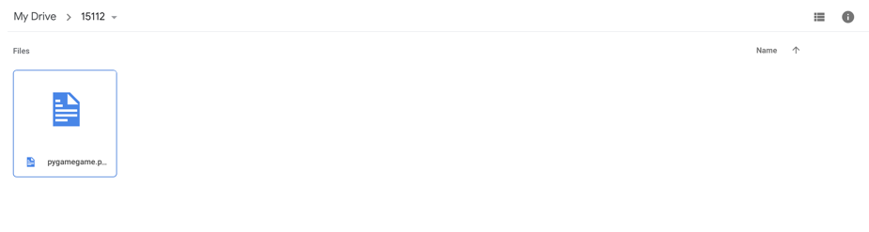

Algorithmic Plan:

the hardest part of the coding is to make sure the ball does not go over the boarder at all; to do this I will try to detect the color pixels around the ball’s edges to make sure it does not go off the boarder; in order to test whether the player wins/loses, the best solution would be checking a. If the ball reach the end; b. If the velocity is 0; c, If the acceleration is 0; if acceleration and velocity turn zero before it gets to the end, the player loses the game.

Structure Plan:

Mode:

class(object)

Menu mode

Instruction mode

Setting mode

Solve mode

Play mode (after clicking the play button)

Result mode

Objects:

Class (pygame.sprite.sprites)

Obstacles: readText, draw Obstacles

Balls: drawBall, fall, collide, colorDetect

Letters: drawLetter, moveLetter, deleteLetter

Timer

letterLeft

Score

Timeline Plan:

The first half of the Thanksgiving: finish pages for different modes except for game mode

The second half of the Thanksgiving: finish game mode